Pre-lab

Next time in class, we will have **RNA-Seq workshop I** for processing RNA-Seq files starting from FASTQ till reaching a counts matrix, that could be used for downstream analysis (e.g., differential gene expression analysis).

Our samples are from a recent nature molecular psychiatry paper about suicidality. The study included more samples, but we’re only using a few samples from this paper (just for the galaxy workshop). These are all postmortem, and you can read more about the samples in their paper or on the GEO series.

<https://www.nature.com/articles/s41380-024-02420-z>

<https://www.ncbi.nlm.nih.gov/geo/query/acc.cgi?acc=GSE248260>

These samples are only used in this workshop and will NOT be used in the following workshop (**RNA-Seq workshop II**). Part II will focus on doing differential gene expression analysis using an online shiny app with a completely different dataset.

By the end of RNA-Seq workshop I, you’ll need to submit the counts file for one of the samples you used.

# Galaxy Account

* Got to <https://usegalaxy.org> and create an account.

# Download samples

1. Click on the links below and download the FASTQ files for each sample. Those are large files (~ 1.2 GB each; ~16 GB if uncompressed), so make sure to download them and get them uploaded to Galaxy before coming to class.

<https://trace.ncbi.nlm.nih.gov/Traces/?view=run_browser&acc=SRR26894792&display=download>

<https://trace.ncbi.nlm.nih.gov/Traces/?view=run_browser&acc=SRR26894795&display=download>

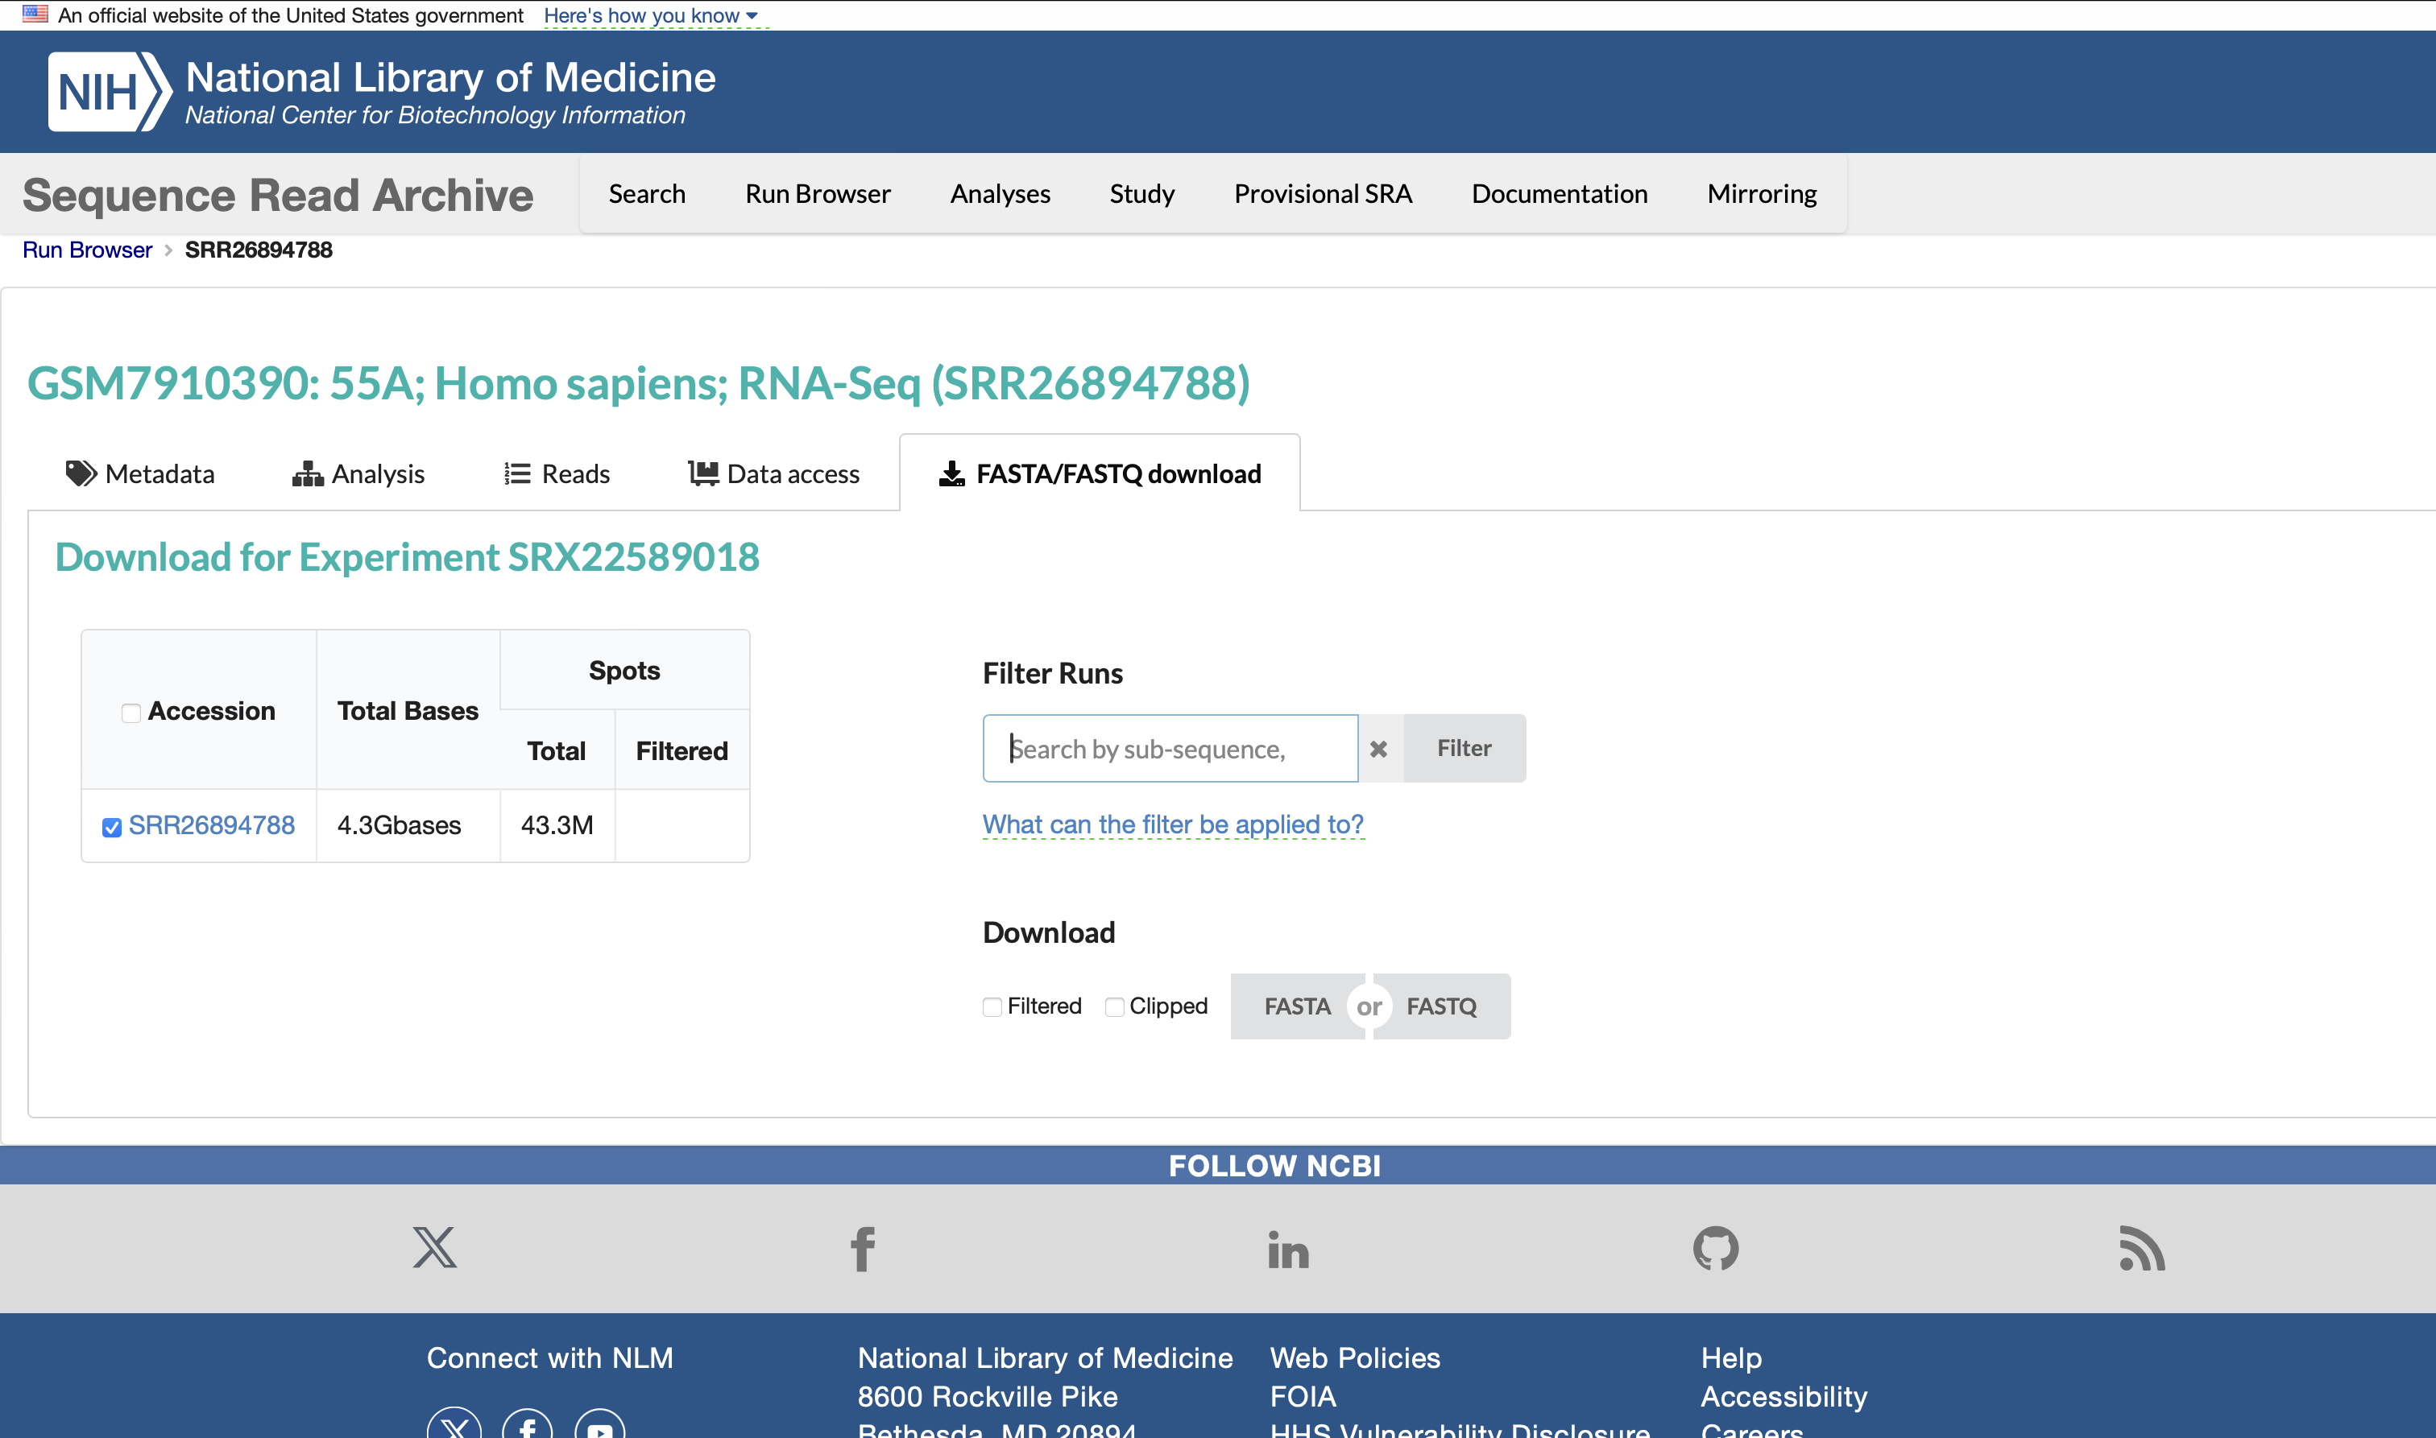

# Getting started

1. Go to and <https://usegalaxy.org> and sign in.
2. Rename the “Unnamed History” to “BfB workshop”

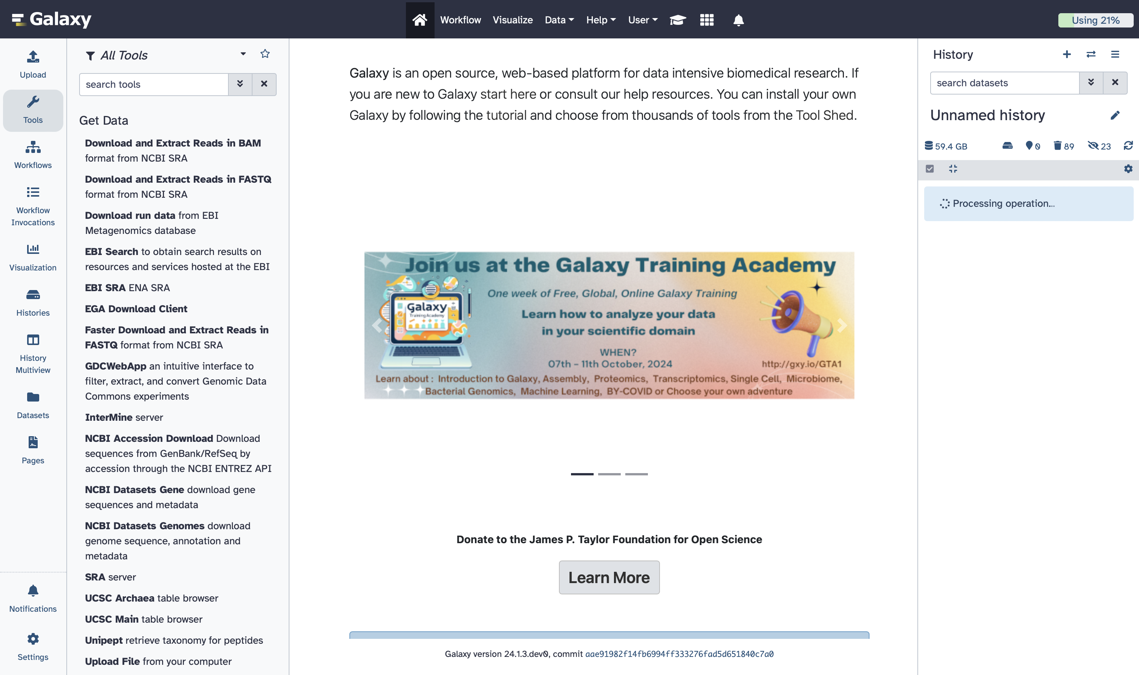

1. Click on upload and choose “Chose local file”.

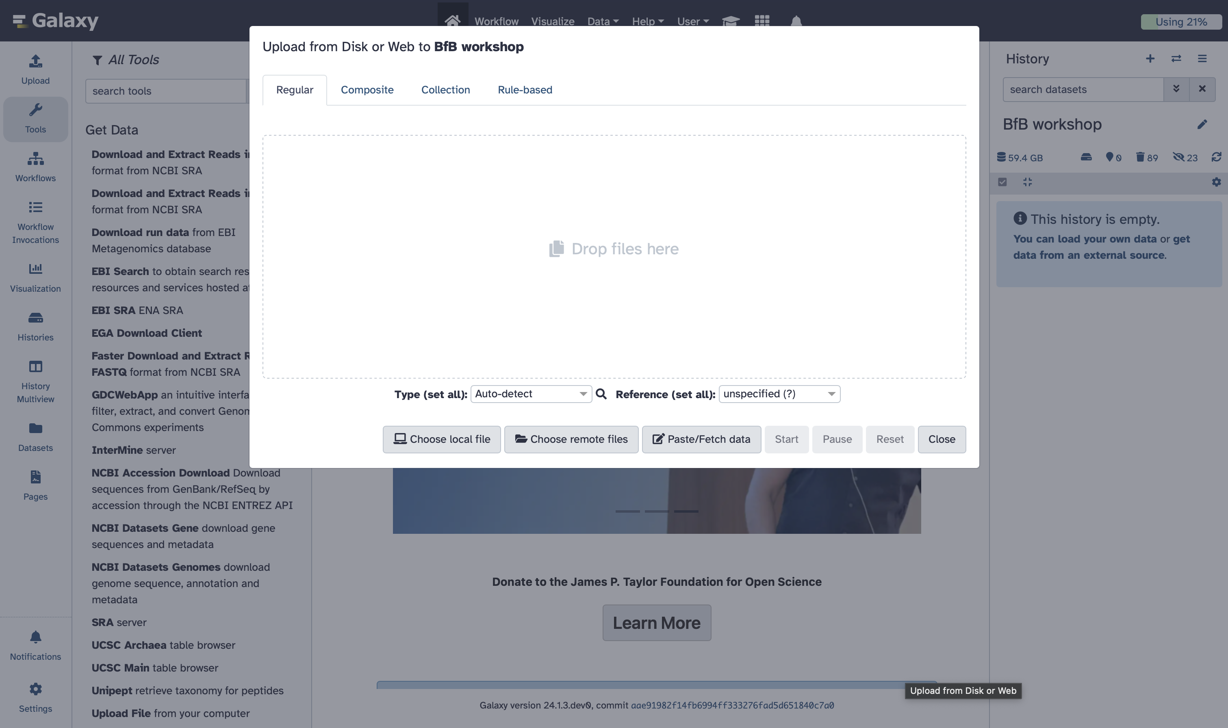

1. Choose the FASTQ files you just downloaded and click on start (this might take up to 30 minutes per file). You can close this window after uploading. If you didn’t finish this step before class, you probably won’t be able to apply what we’re doing live.

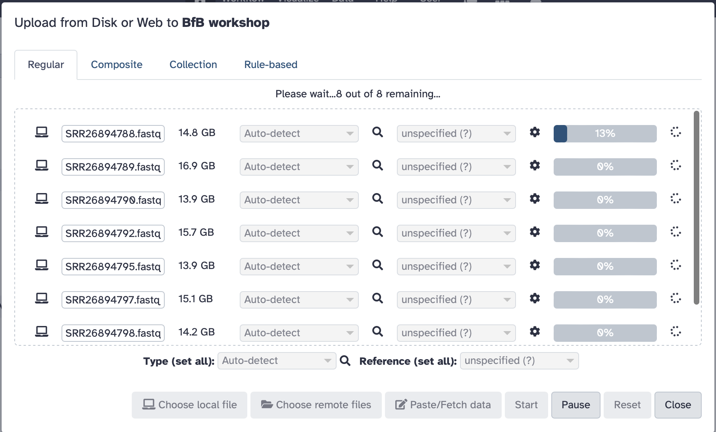

RNA-Seq workshop I:

# Quality Control

1. Type “FastQC” in the search textbox on the left and choose the first one.

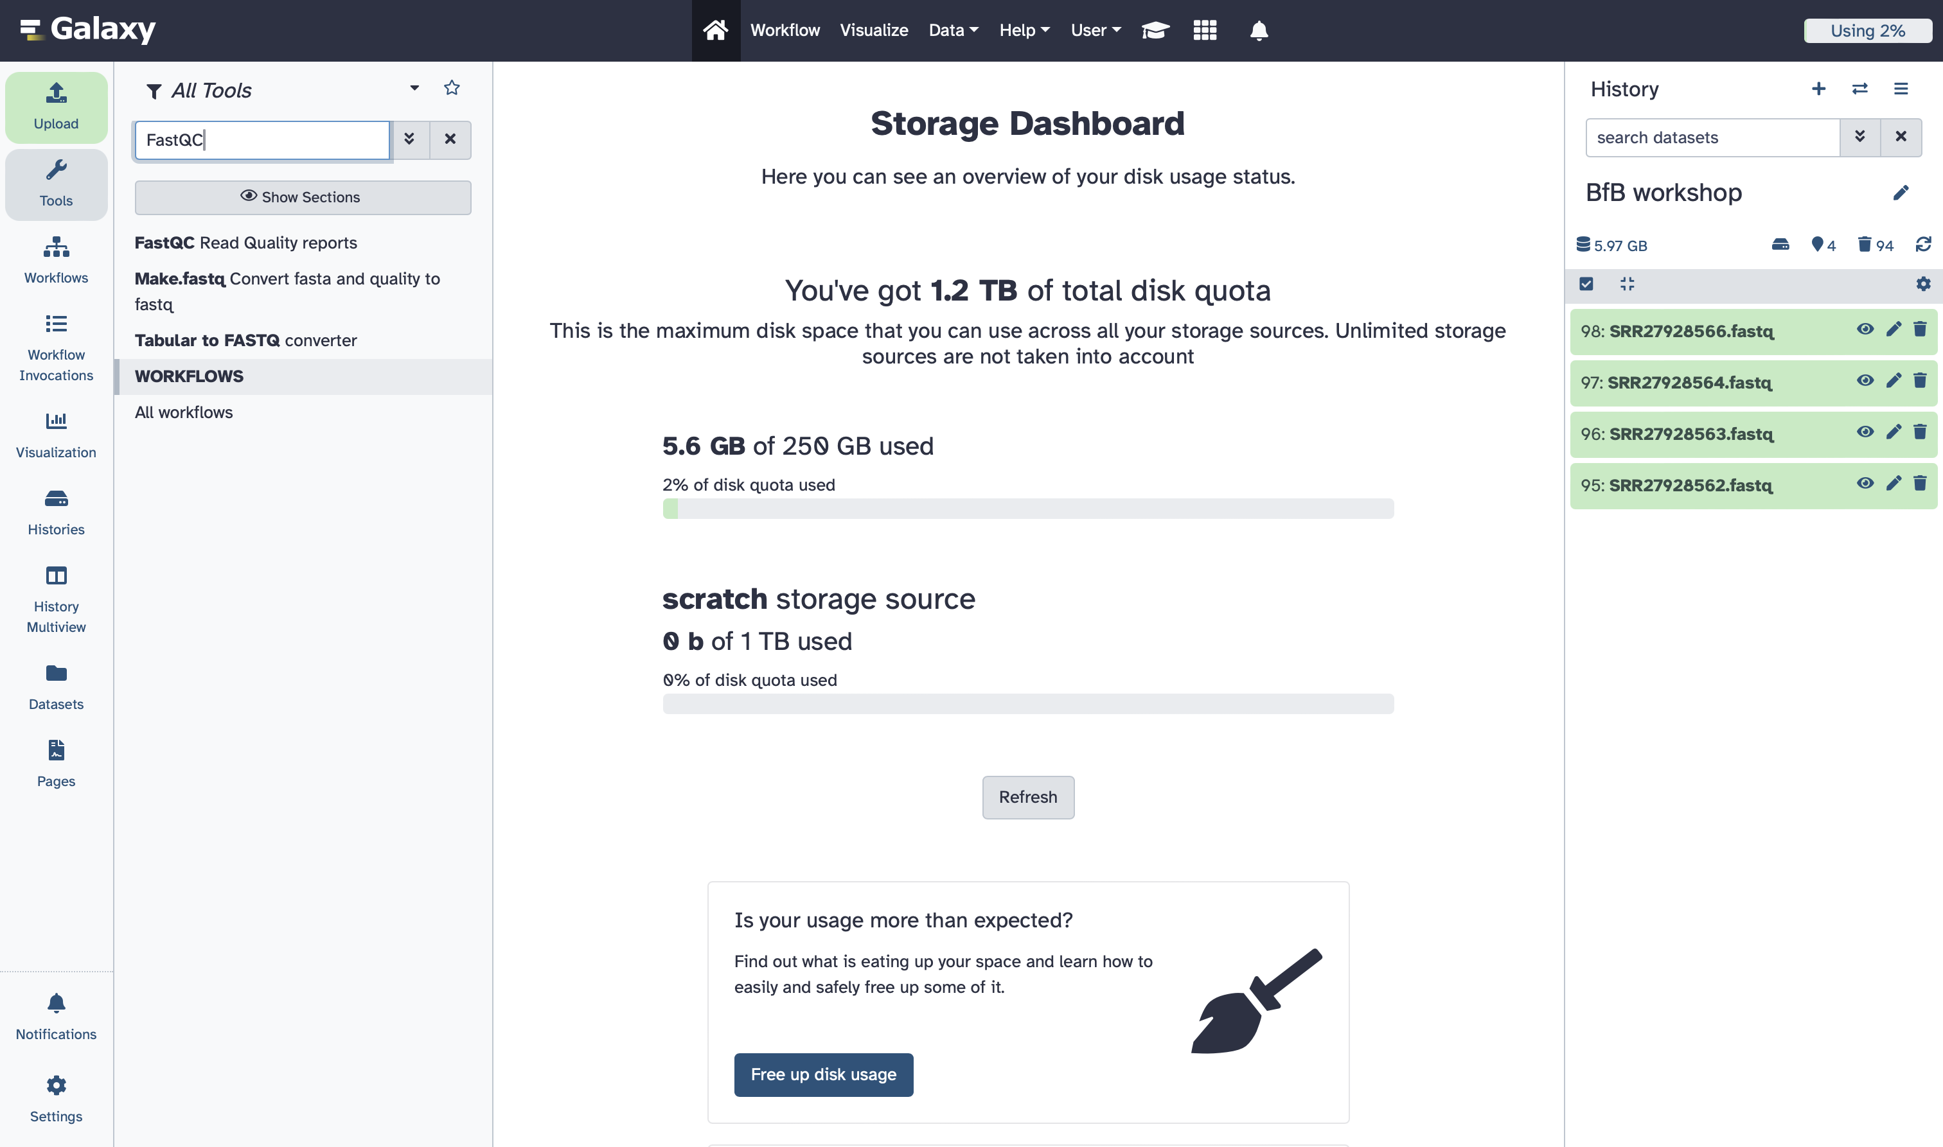

1. Click on “Multiple datasets” option and choose all uploaded fastq files. Then, scroll down and click on “Run Tool” or click on “Run Tool” at the top right.

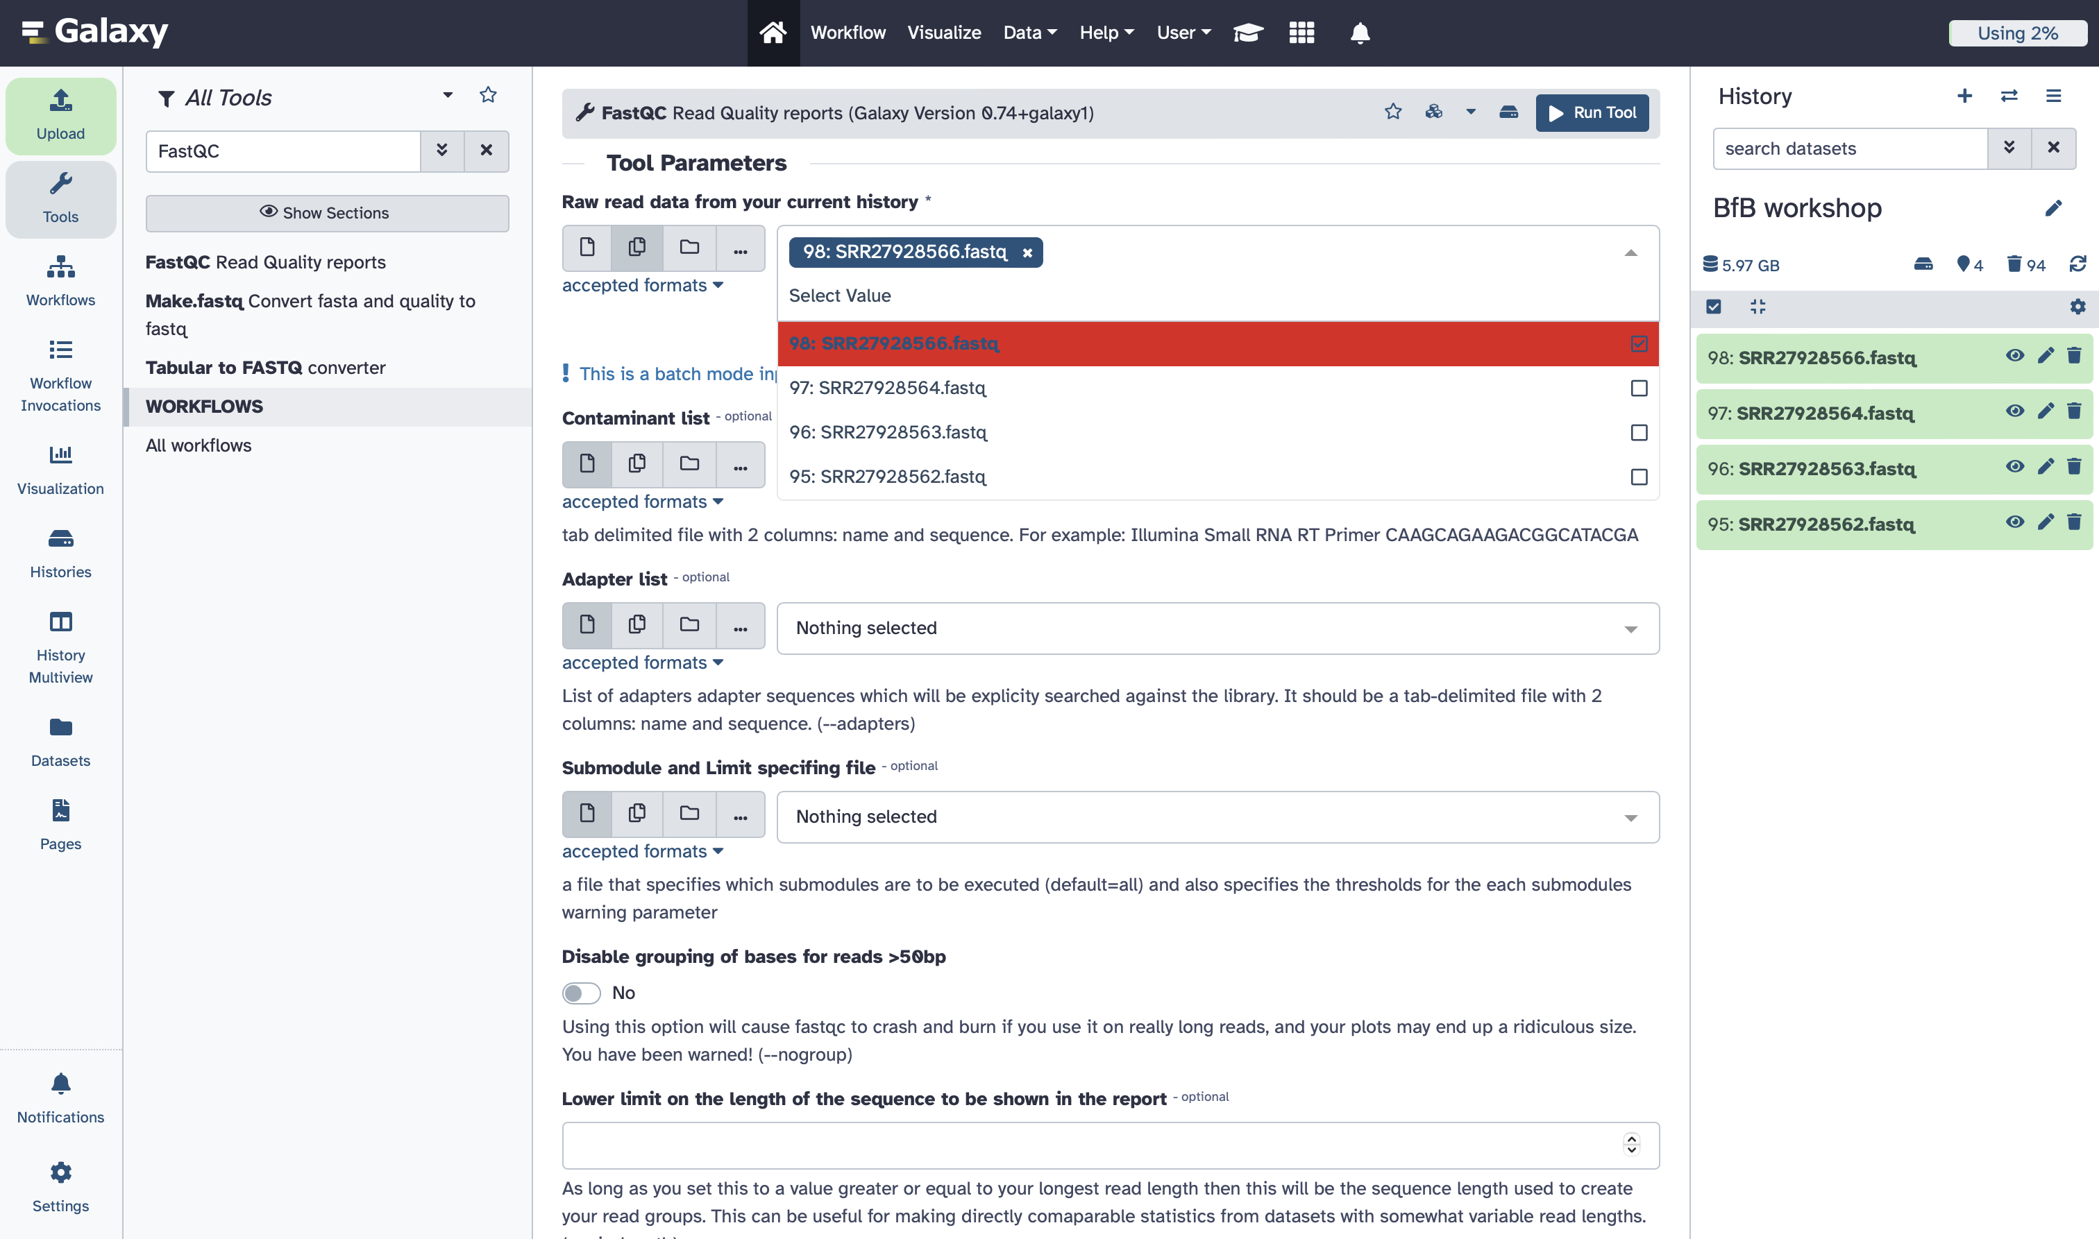

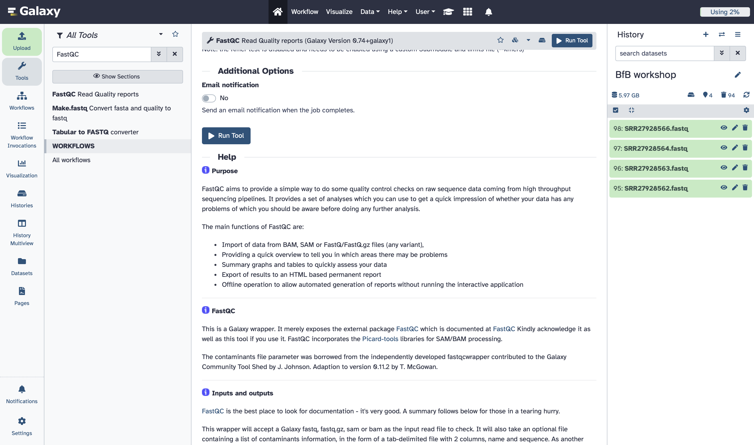

1. If you want to view the QC output for one of the samples, click on the view icon on the newly generated webpage file. You can also download it and open the pdf.

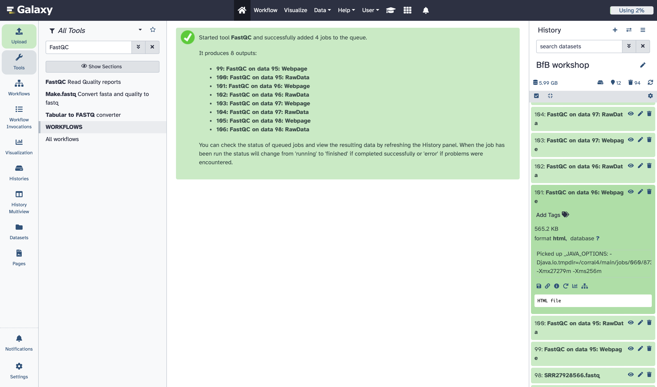

1. Instead of looking at the FastQC results file per sample, we can combine all samples’ results together in 1 report. Search for MultiQC tool on the left side and choose the first one.

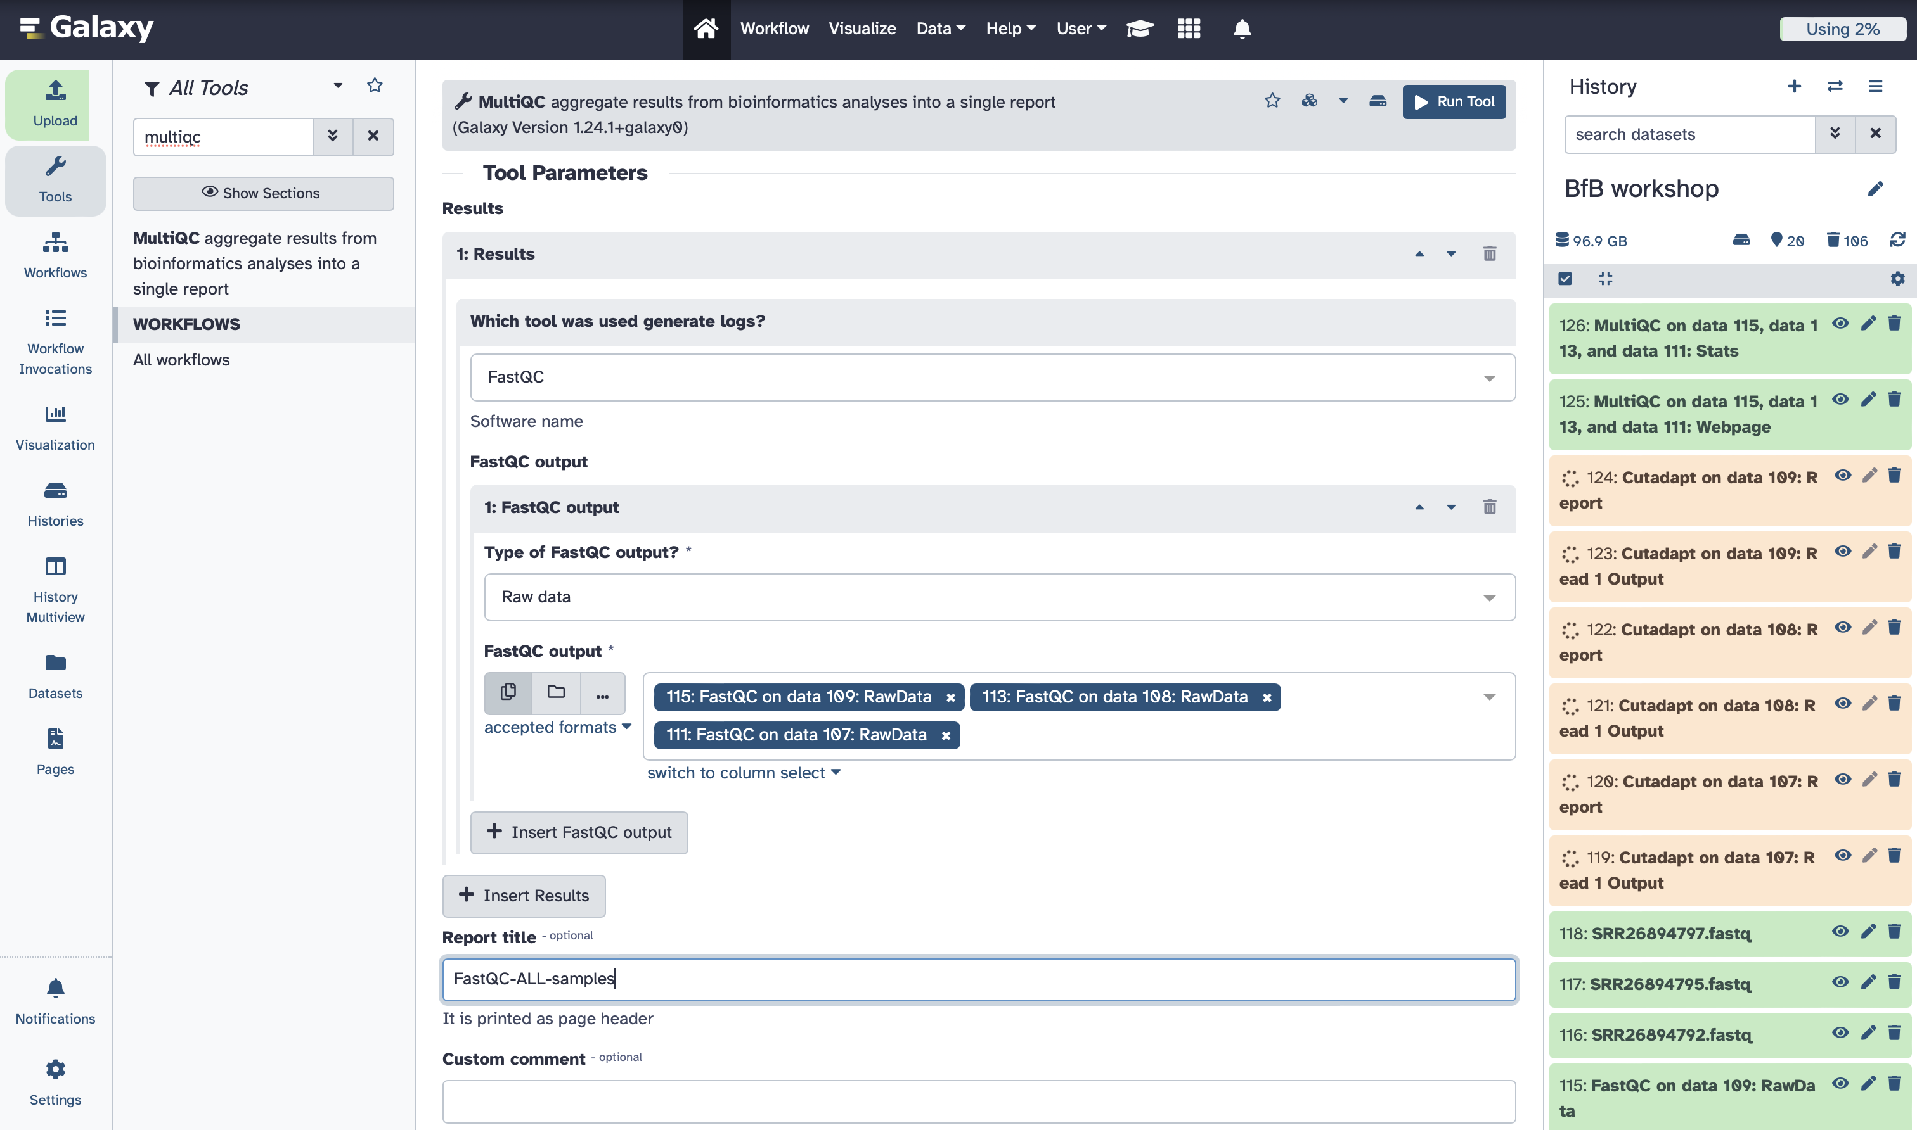

1. Choose “FastQC” in the dropdown menu under “Which tool was use to generate logs?”

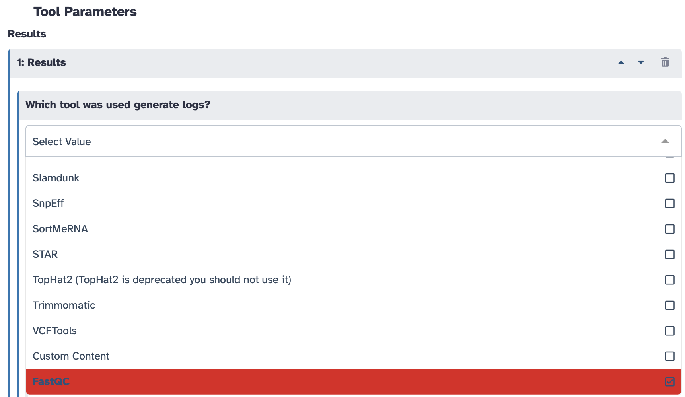

1. Choose “Raw Data” under the “Type of FastQC output?” and then select the “.RawData” files that were given as an output by FastQC. Add a name to the output report as “FastQC-ALL-samples”



1. Once it’s done with generating the report, check the output webpage by clicking on the view aye sign. This report should help you decide on what steps you need to take in the following step. For example, do you need to trim bases from the read ends? Do you need to trim adapters? Do you need to drop any reads that don’t match certain criteria?

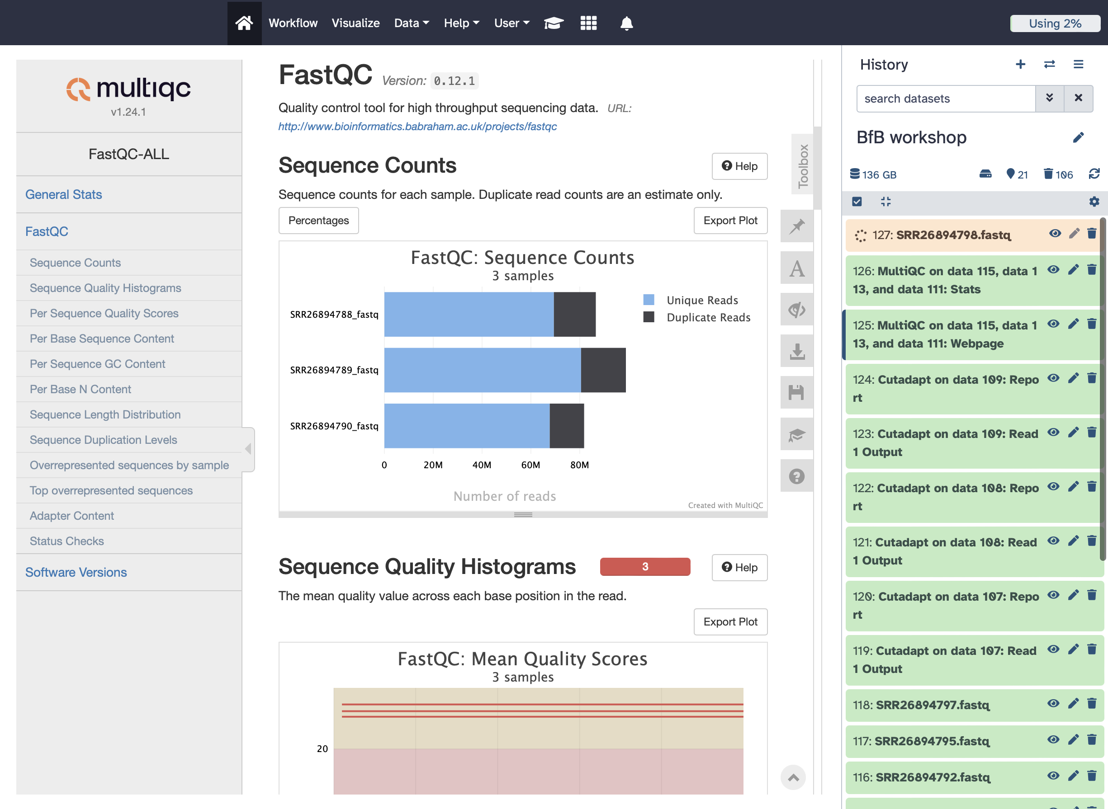

1. You might need to apply trimming (cutting ends of the read) depending on your data. You can use the “Cutadapt” tool to remove adapter sequences. Choose the first one from the search list.

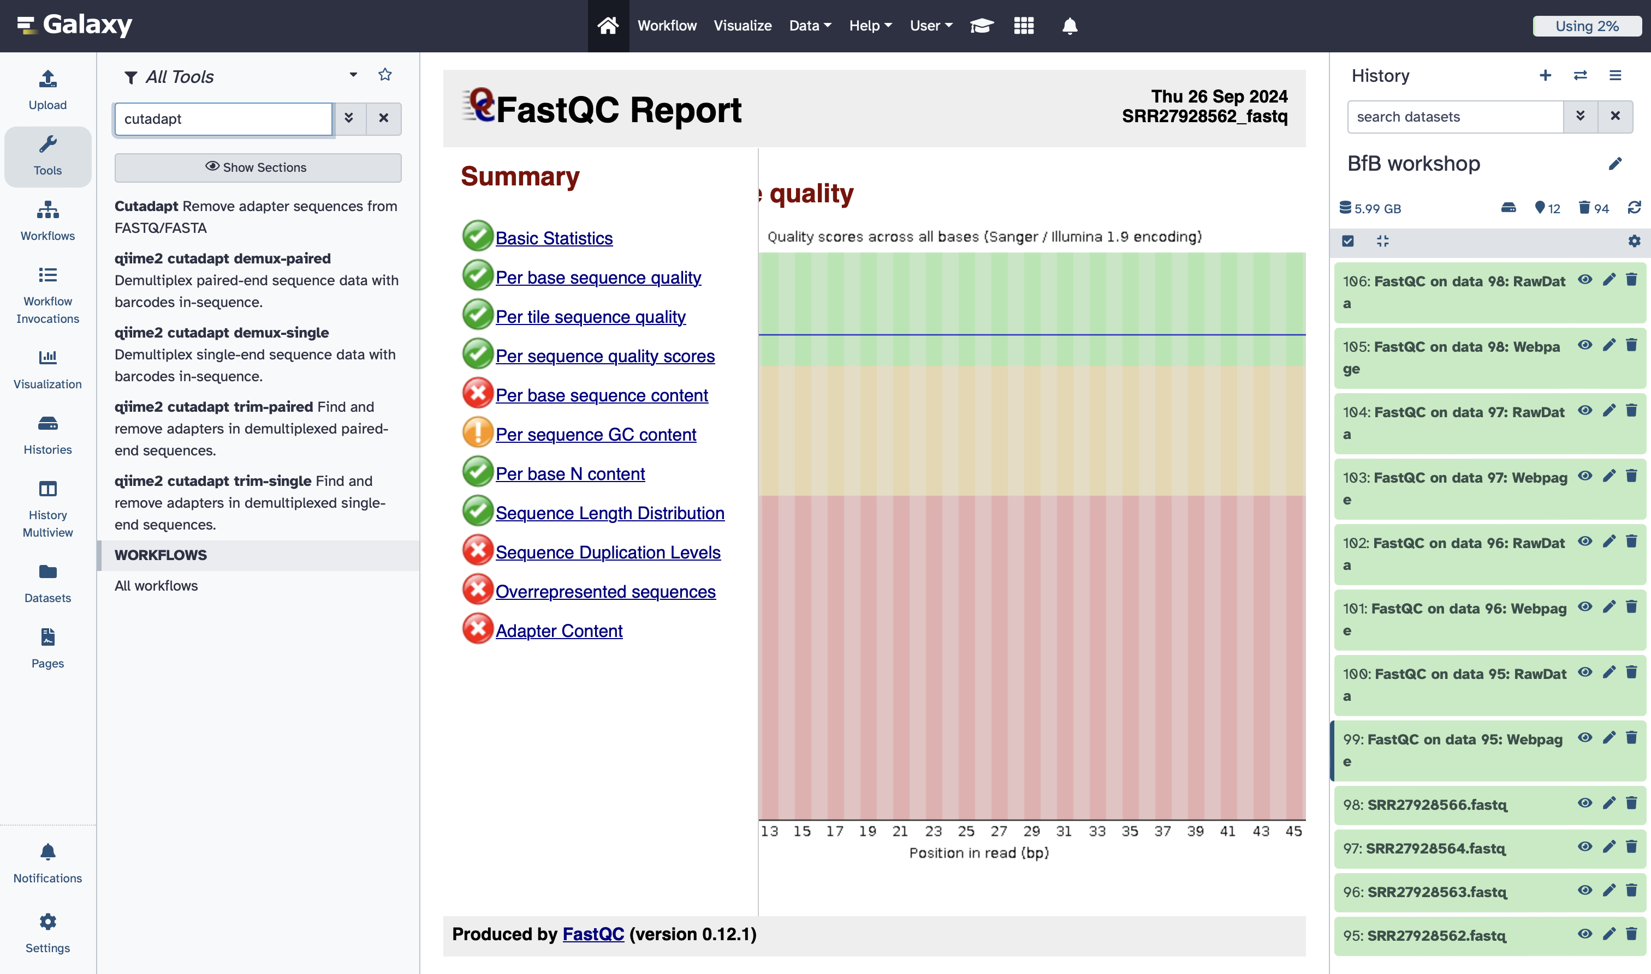

1. Select either Single-end or Paired-end based on your data. The ones we have in this workshop are Single-end. Then, click on “Multiple datasets” and select all fastq files you have.

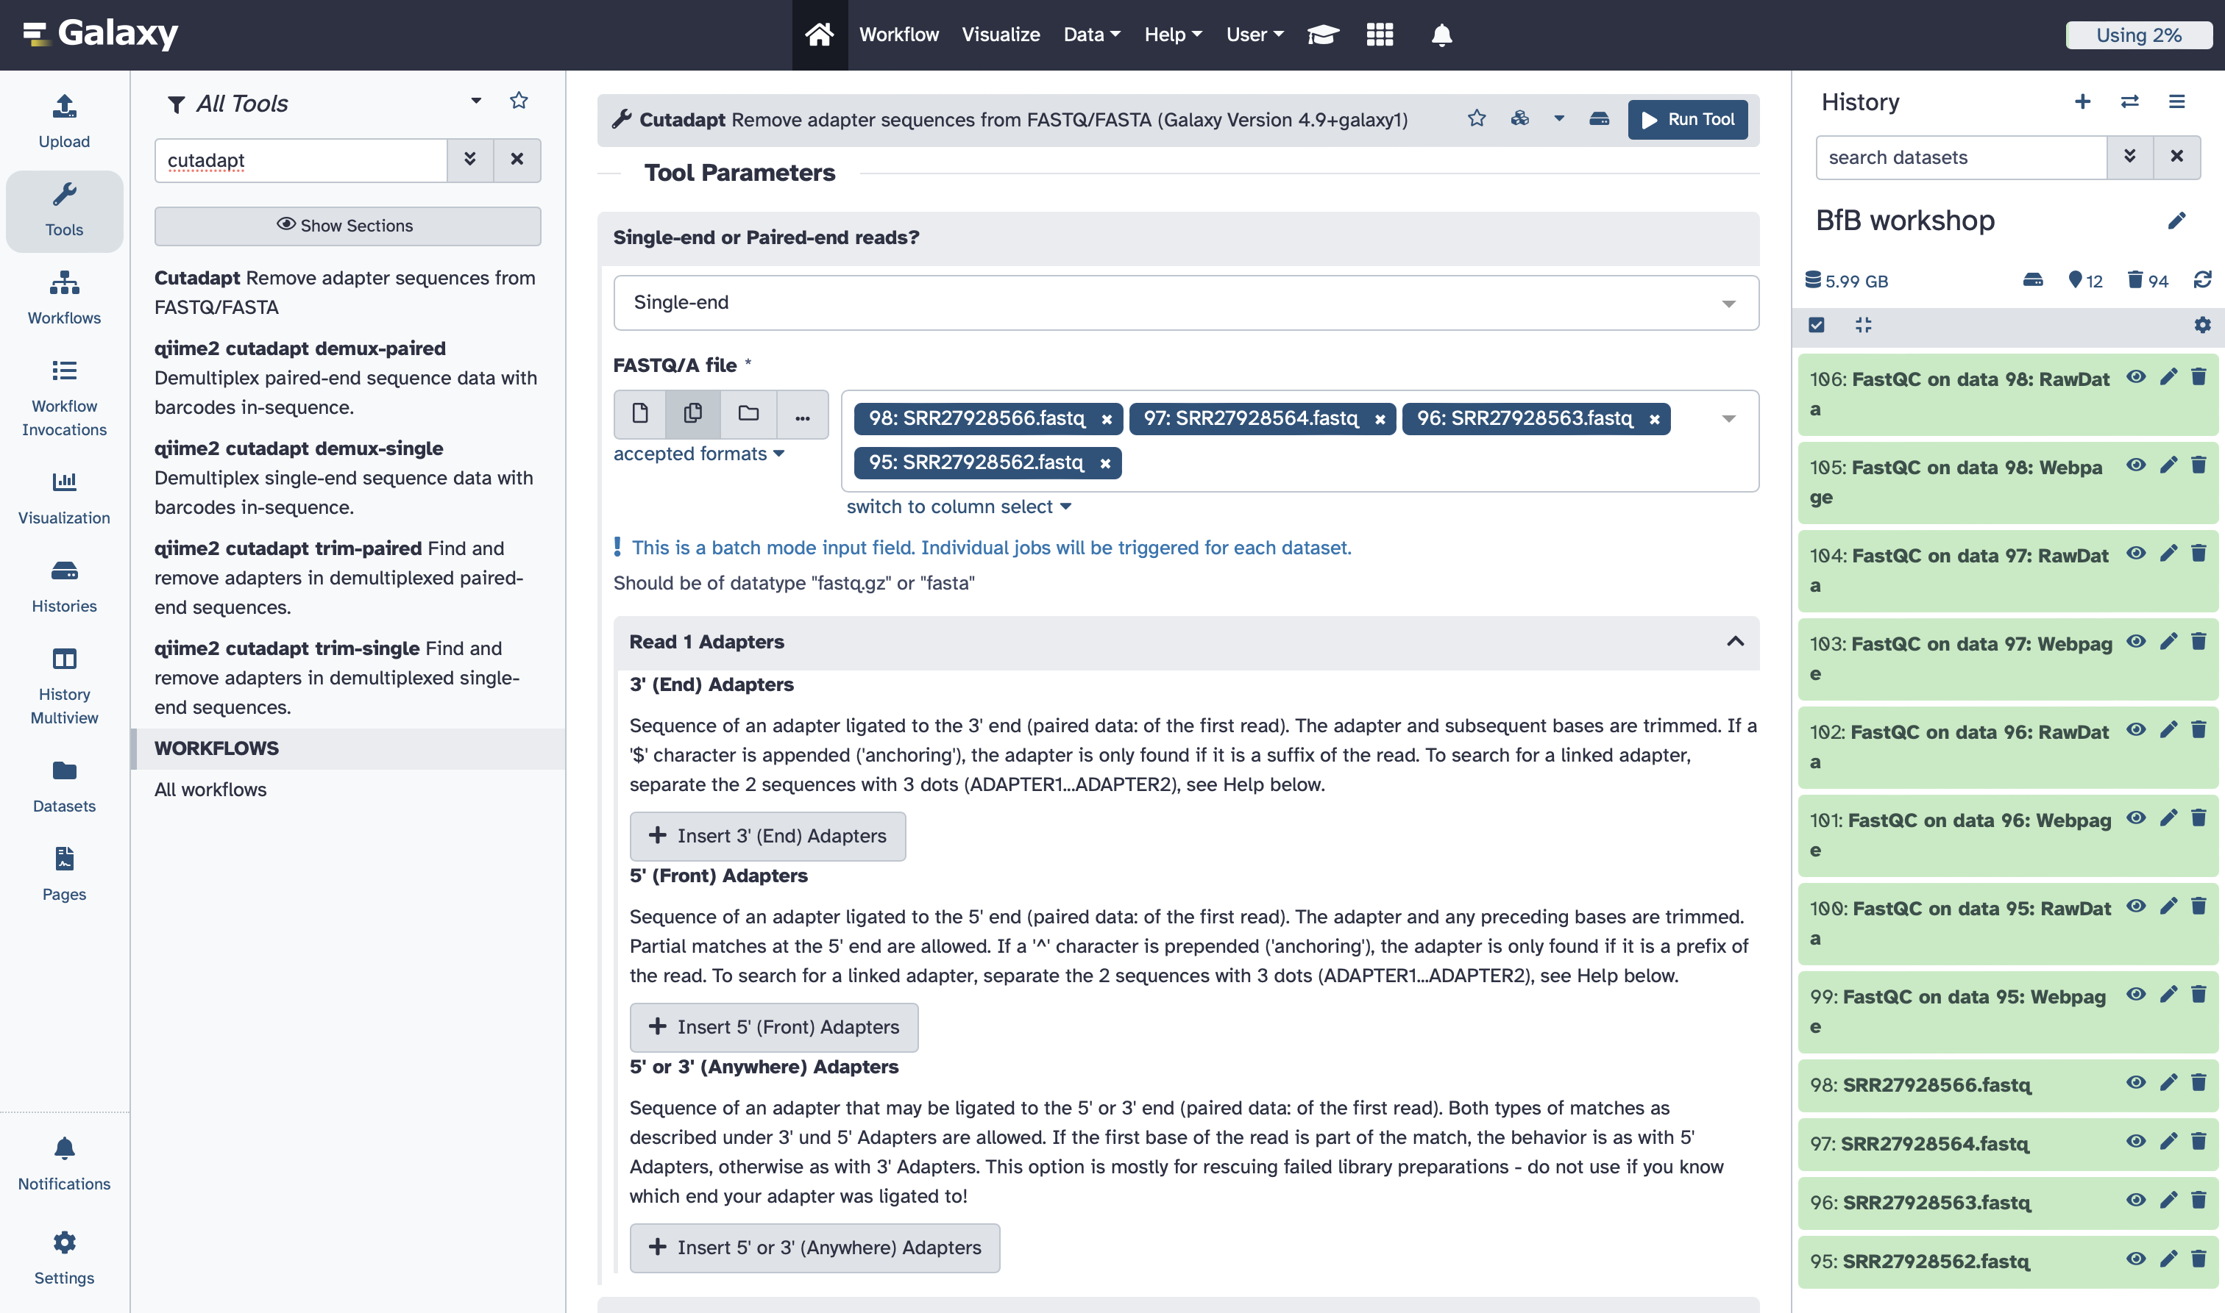

1. Click on the “Read Filtering Options”. Since our samples are single-read, we will only adjust the settings for R1. Change the Minimum length (R1) to 20 (this is length threshold for reads).

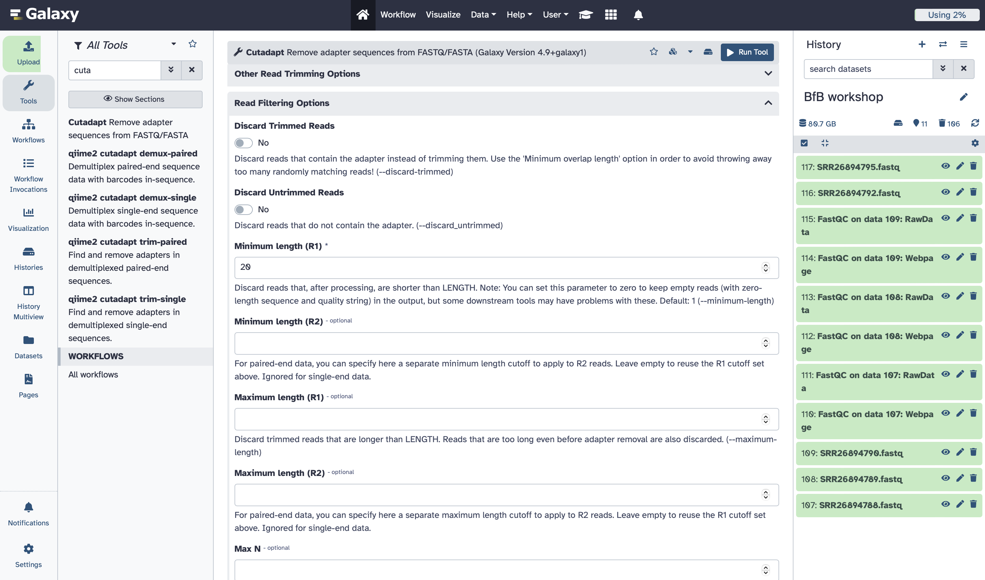

1. Check the box for “Report: Cutadapt’s per-adapter statistics..” under the “Additional outputs to generate” section. Click on “Run Tool” when you’re done.

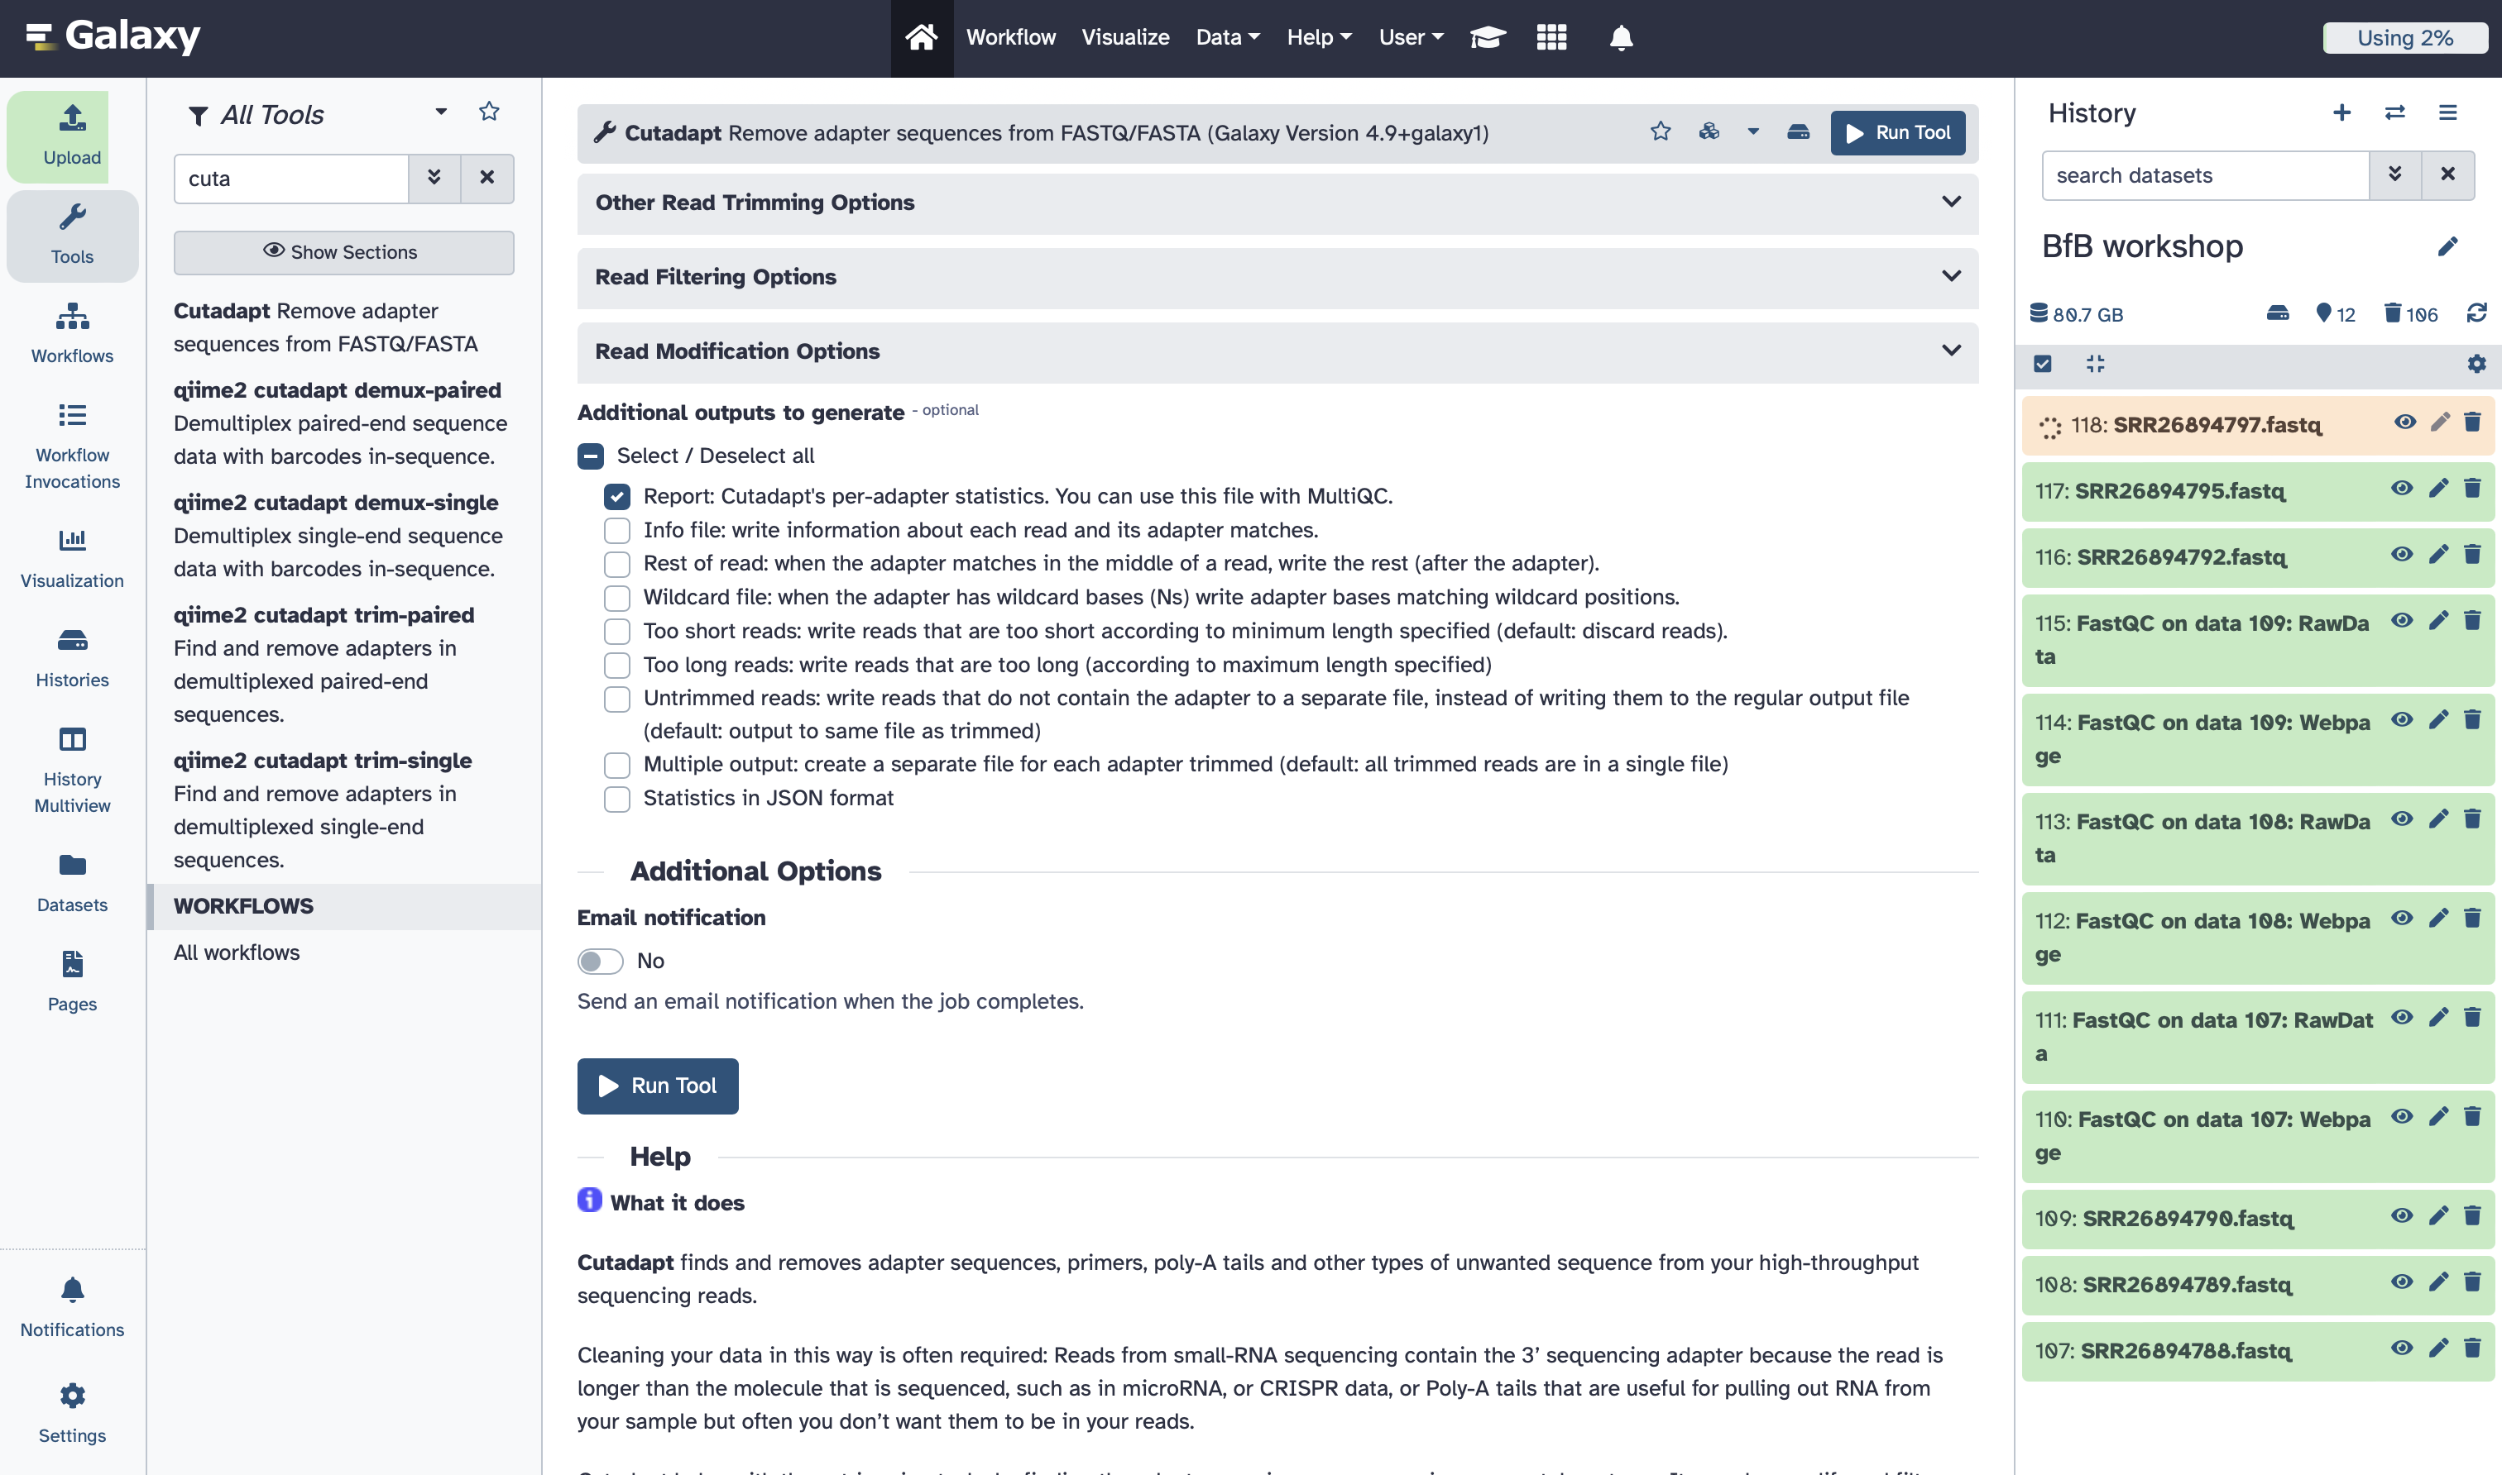

1. Again, you can combine the results of “Cutadapt” in one report using MultiQC tool (see steps above). Change the report title to be “cutadapt-ALL-samples”. And then “Run Tool”.

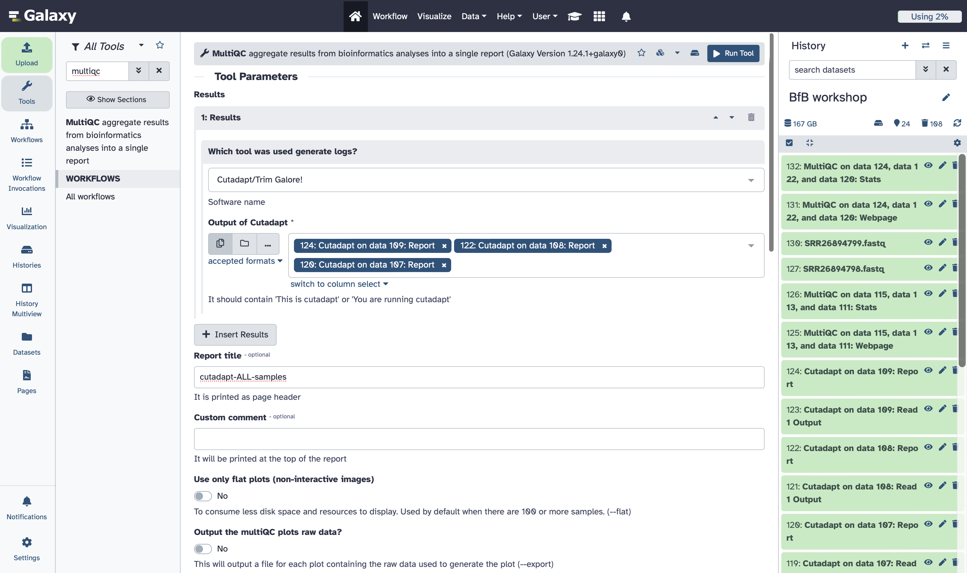

1. View the report and see if anything was trimmed from your samples.

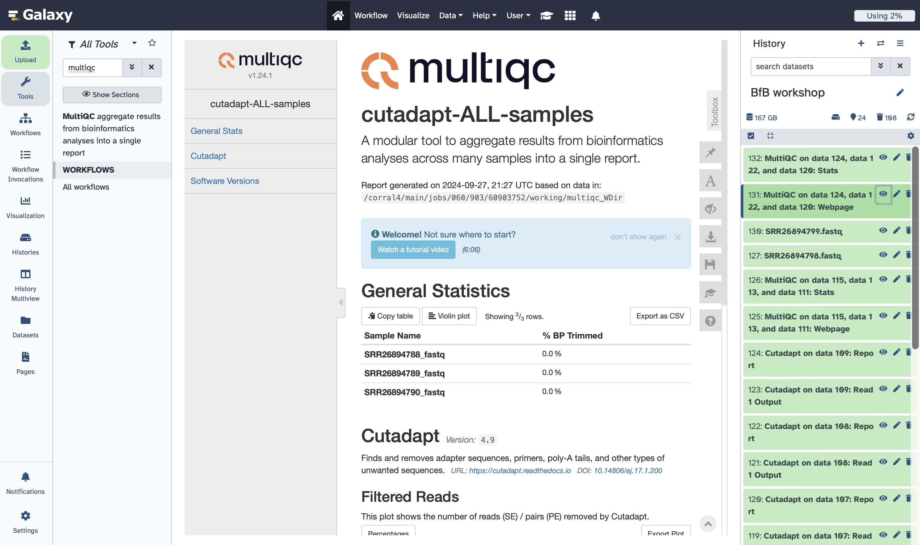

# Alignment

1. Search for “RNA STAR” in the tools search box

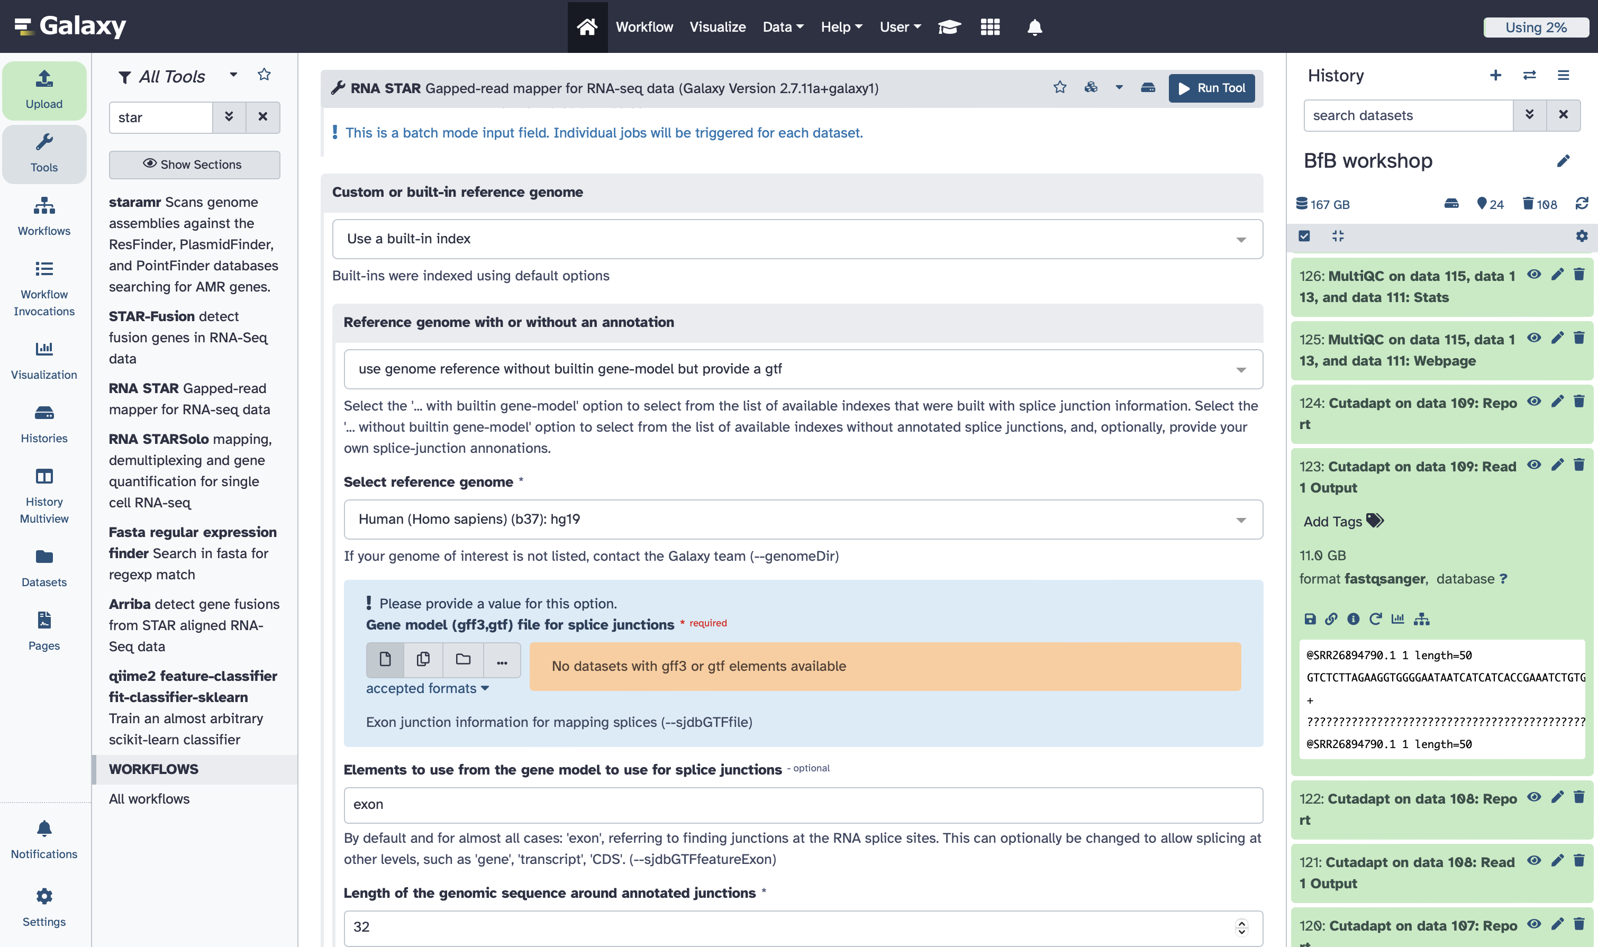

1. Choose “Single-end” and select the output files from cutadapt (you want to use these files if you already did some trimming)

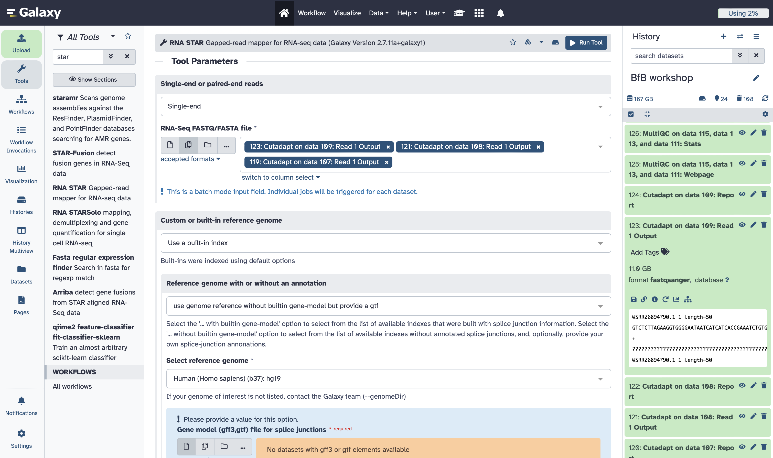

1. Choose hg19 as a reference genome. If you can’t find the reference genome of the organism you want, you can simply choose to upload a reference genome. Click “Run Tool” when you’re done with this.

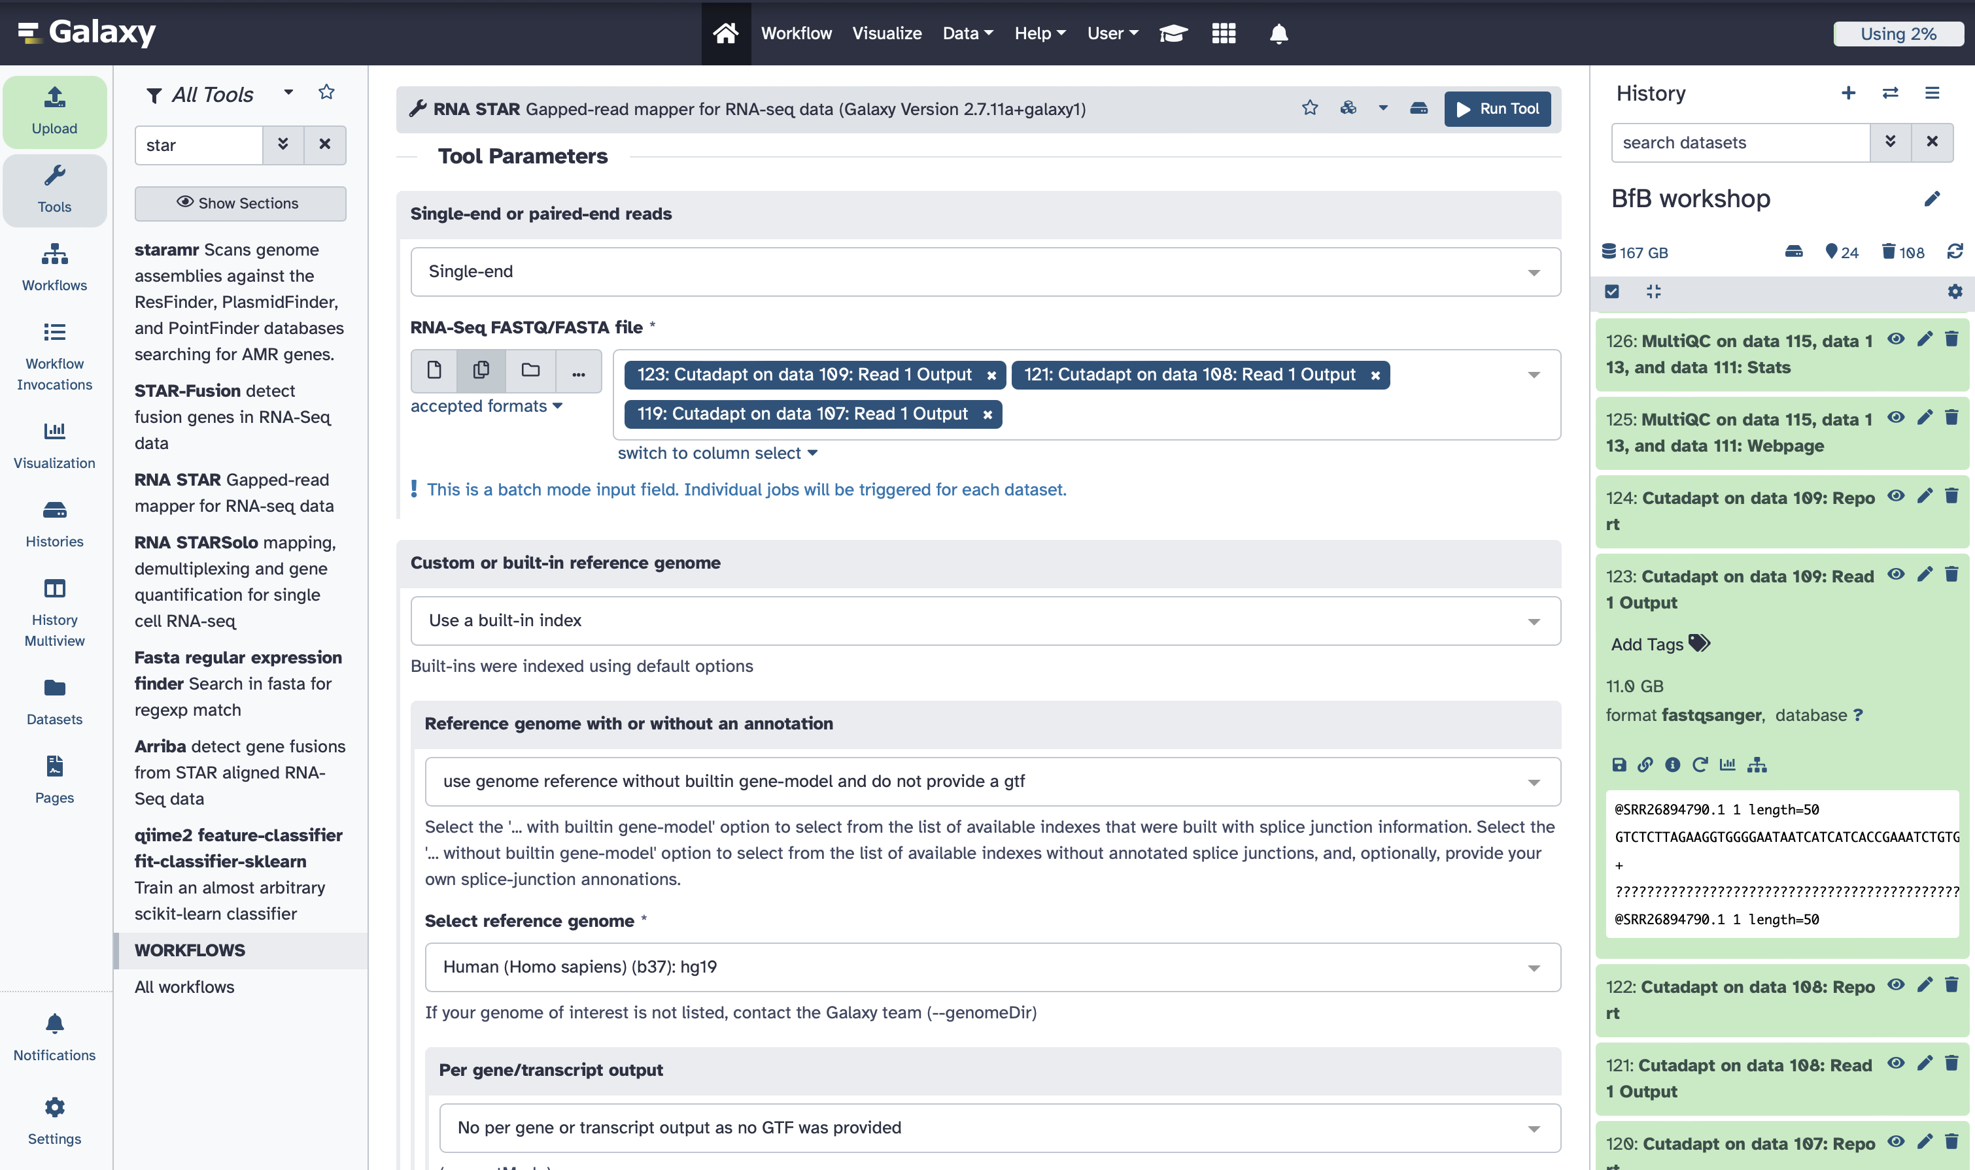

1. After STAR jobs are done running, combine all of their log files using MultiQC and use “STAR-ALL-samples” as a report title.

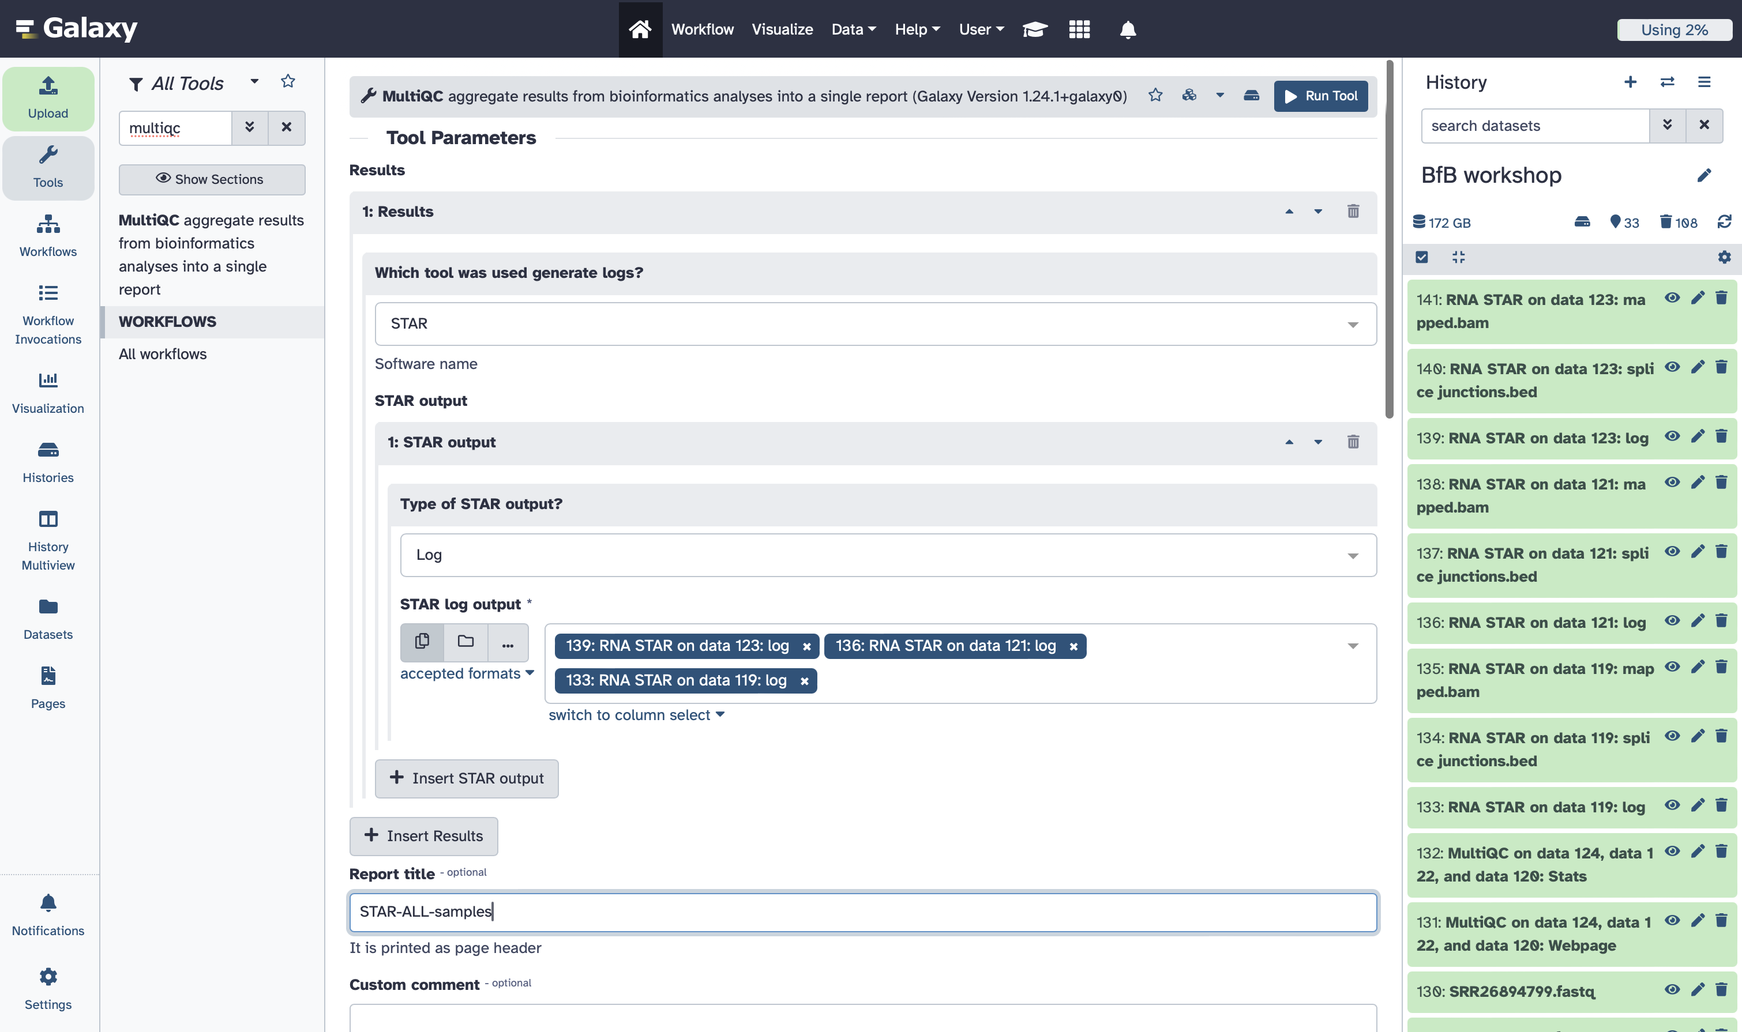

1. Check the MultiQC report. It should show you the STAR alignment statistics, including percentage and number of mapped reads. We can proceed with the analysis since only percentages below 70% should be investigated for potential contamination.

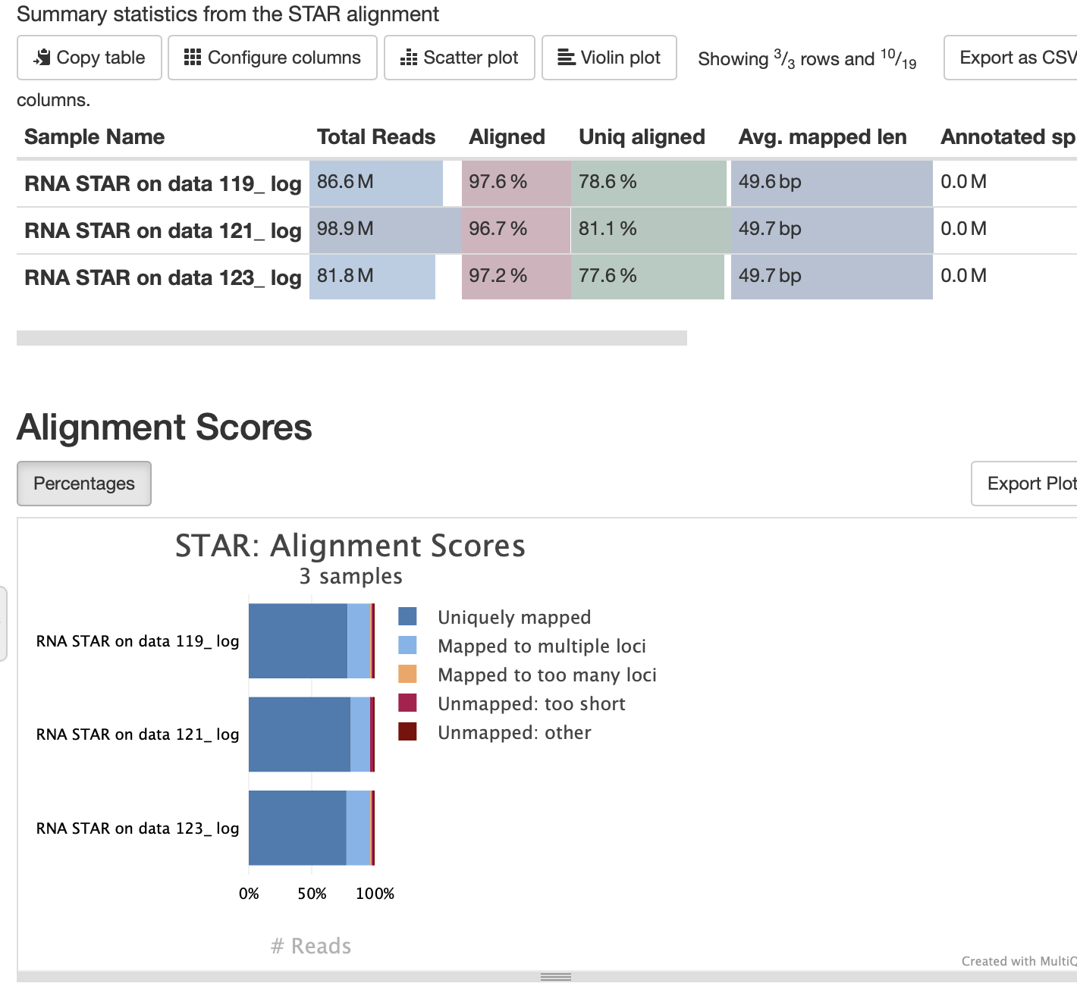

# Counting Reads per Gene

1. There’re multiple tools that can do reads’ counting. We will use “FeatureCounts” here. Type “FeatureCounts” in the tool search box and choose the first tool in the list.

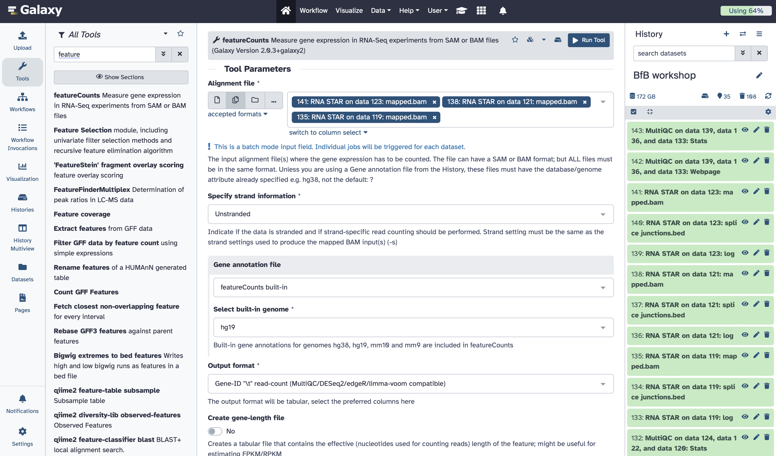

1. Under the “Tool Parameters” section, choose all the bam files (STAR output).



1. Keep the “Unstranded” option by default in the “Specify strand information”



1. Choose “featureCounts built-in” option for gene annotation. If you did the alignment in STAR using another reference, that you uploaded, you will need to upload another file here for gene annotation. Choose the built-in genome hg19 (make sure you choose the same reference build you chose for STAR alignment).



1. Keep the default output format as below, change the minimum read quality to 10, and then run the tool.



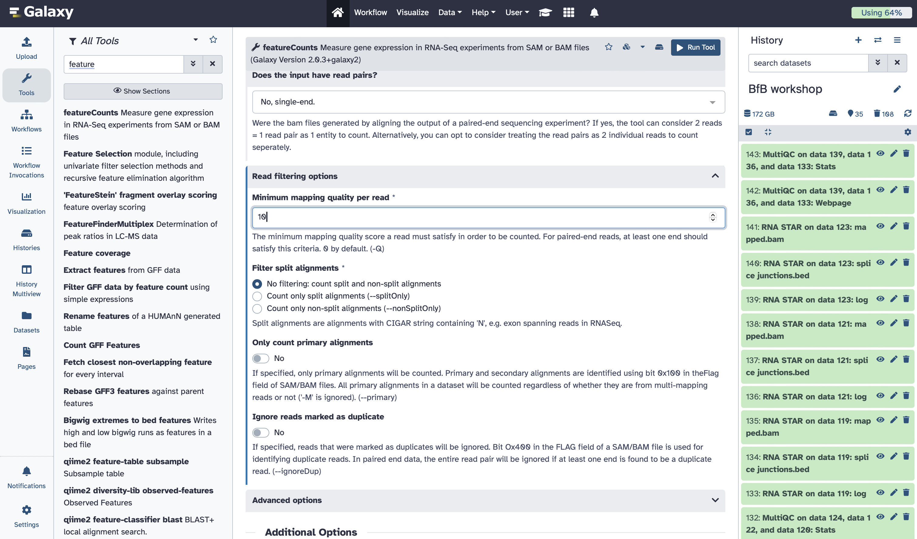

1. Again, combine all reports together using MultiQC and use the “faetureCounts-ALL-samples” as a report title.

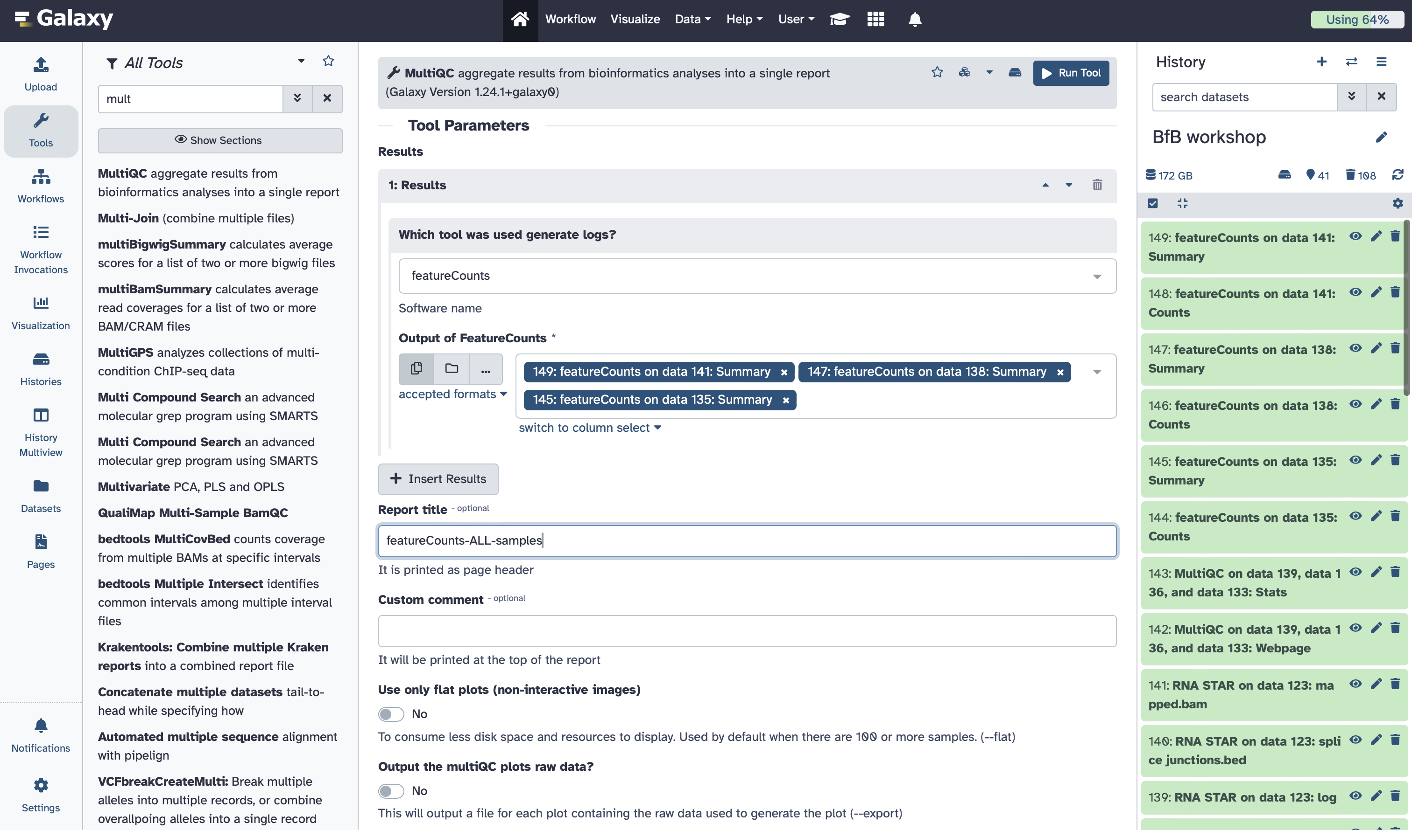

1. You can check the output by viewing the counts of one sample

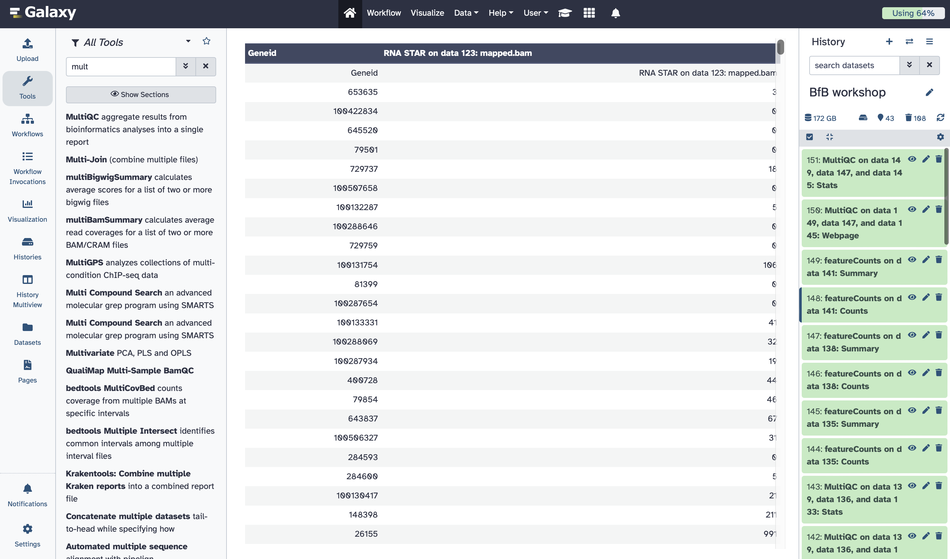

# ICON questions:

1. How confident do you feel about processing your own RNA-Seq data on galaxy? (give a number from 1-10; 1 not confident at all and 10 very confident)
2. Upload a screenshot of your galaxy home showing all data in your workshop history.
3. Upload the counts file for one of your samples.
4. What are possible areas of improvement for this workshop? (i.e., what concepts could’ve been explained better or in another approach?)
5. Rate this workshop (give a number from 1-10; 1 needs a lot of work and 10 great)

# Pre-lab

This will be the first 4 pages in this word document, in addition to the following questions:

* Did you download the FASTQ files from SRA?
  + Yes
  + No
* Did you create an account on galaxy?
  + Yes
  + No
* Did you upload all samples on galaxy?
  + Yes
  + No
* Check the concepts you’re familiar with, and comfortable explaining them in class: (check all possible boxes)
  + Demultiplexing
  + Alignment
  + Normalization
  + TPM
  + Sequencing depth

|  |  |
| --- | --- |
| **SRR26894795** | Control |
| **SRR26894797** | Control |
| **SRR26894798** | Control |
| **SRR26894799** | Control |
| **SRR26894792** | Suicidal |
| **SRR26894790** | Suicidal |
| **SRR26894789** | Suicidal |
| **SRR26894788** | Suicidal |